A broad scale summary of existing early warning systems in Kenya and regional initiatives in the Greater Horn of Africa
Table of Contents
1. Introduction 2
2. Existing EWS in Kenya 2
2.1. The Kenya Meteorological Department 3
2.1.1. KMD indicators, thresholds and early warning information 3
2.1.2. What does forecast decision making in KMD look like? 8
2.1.3. Emerging issues for KMD early warning information related to FbA 9
2.2. The National Drought Management Authority 10
2.2.1. NDMA DEWS indicators, thresholds and early warning information 10
2.2.2. What does the NDMA system and decision making look like? 13
a) National drought management policy 13
b) Drought early warning information system 14
c) County contingency (‘shelf’) plans 14
d) Drought contingency (response) fund 15
e) Drought coordination and response structures 16
2.2.3. Emerging issues for NDMA EWS related to FbA 16
2.3. The Famine Early Warning Network (FEWS NET) 17
2.3.1. FEWS NET indicators, thresholds and early warning information 18
2.3.2. What does the FEWS NET system and decision making look like? 21
2.4. Mapping existing EWS in Kenya to a people-centred approach (FbA) 23
3. Regional EWS initiatives in the GHA 24
3.1. IGAD Integrated Regional Early Warning system (IREWS) 24
3.2. Africa RiskView (ARV) 24
3.3. Food Security and Nutrition Working Group (FSNWG) 25
3.4. Global Information and Early Warning System on Food and Agriculture (GIEWS) 26
3.5. Emerging issues for regional EWS related to FbA 26
4. Relatively light touch political economy analysis in Kenya 27
4.1. Agenda setting documents for disaster risk management 28
4.2. Institutions involved in disaster risk management in Kenya 30
4.3. Coordination platforms for disaster risk management in Kenya 30
4.4. Emerging issues for EWS political economy 33
References 34

- Introduction
Significant economic and livelihood losses have been caused by droughts and floods in Kenya. While accurate data on the economic costs of drought does not exist in Kenya (Mbogo, Inganga, & Maina, 2014), it is estimated that between 2008 and 2011, damage and losses caused by droughts was USD 12.1 billion. This slowed the country’s Gross Domestic Product (GDP) by an average of 2.8% per annum. In 2011 alone, drought affected 3.75 million people at a cost of USD 427.4 million in humanitarian aid (Kenya Ministry of Devolution and Planning, 2015). Most recently, the 2016/17 drought left about 1.25 million people acutely food insecure by January 2017 (WFP, 2017). In February 2017, the Kenya Government declared drought a national disaster, with a Government budget allocation of KES 11 billion (about USD 110 million) for drought response interventions in various sectors (Office of the President, 2017). By March 2017, the number of people who were acutely food insecure had risen to 2.6 million, resulting in an international flash appeal for USD 165.7 million required to provide humanitarian assistance over the following 10 months.
Impact and cost implications for floods are less well documented compared to droughts. The 1997/98 El Nino floods are most commonly mentioned, as they are considered as one of the largest flood losses in the country over the last 50 years. Economic costs were estimated to be between USD 0.8 to 1.2 billion, arising from damage to infrastructure (roads buildings and communications), public health effects (including fatalities) and loss of crops (GoK, 2012).
Frequency and severity of extreme drought and flood events is exacerbated by climate change. Estimates indicate that the cost of extreme events may take up around 2.6% of Kenya’s GDP each year by 2030. Lives, livelihoods and economies in countries in the Greater Horn of Africa (GHA) are equally, if not more vulnerable to the impacts of extreme weather and climate events. This has placed emphasis on climate risk management in economic and livelihood planning and development in Kenya and the GHA Region. A key part of climate risk management is the development and operationalisation of early warning systems (EWSs).
The ForPAc project aims to analyse and map out the EWS decision-making processes, contexts and capacities, so as to identify likely requirements for Forecast based Action (FbA). This report presents a broad scale summary of existing EWS in Kenya and regional initiatives in GHA.
A commonly used definition of an EWS is the set of capacities needed to generate and disseminate timely and meaningful warning information to enable individuals, communities and organizations threatened by a hazard to prepare and to act appropriately and in sufficient time to reduce the possibility of harm or loss. (Habilov, et al., 2015) argue that consensus does not exist over the meaning of the terms “early”, “warning” or “system”. Different sectors of society need different amounts of time to respond. What may be “early” for some populations is insufficient time for others. “Warnings” may range from broad outlooks to specific alerts, while historical trends offer a form of warning. Others claim that warnings must give future projections. A “system” may be composed of sub-systems that include mechanisms for forecasting, transmission and reception.
The EWSs analysis is guided by the EWS definition above. It reviews early warning information generated and the systems with consideration of review decision-making processes within EWS including organisational procedures. Emerging issues related to FbA are presented in the different sections. A relatively light touch political economy analysis is presented at the end of the report.
- Existing EWS in Kenya
A search for and review of literature revealed that the major EWSs that exist in Kenya are:
- Forecast information developed by the Kenya Meteorological Department (KMD), referenced with regard to drought and flood risk management,
- The drought EWS operated by the National Drought Management Authority (NDMA), and
- The Famine Early Warning Network (FEWS NET), which is mostly mentioned in relation to managing drought risk impacts on food security.
In a 2017 survey, NDMA and KMD are listed among eight major institutions whose mandate play’s a key role in the country's disaster preparedness (Development Initiatives, 2017). Considering that 80% of Kenya is categorised as arid and semi-arid land (ASAL), food security is an important concern for the country’s development. It therefore follows that FEWS NET comes up as a key early warning system, in addition to NDMA.
The three EWSs cover ForPAc demonstration case studies on Kenya drought EWS, flood hazard in the Nzoia River Basin and Urban flood in Nairobi County. Organisations involved with the ALERT project case study interact with the three EWSs as users of early warning information. The sections that follow present a detailed summary and analysis of the three EWS.
  - The Kenya Meteorological Department
KMD’s work focusses on providing meteorological, hydrological and related services, towards the safety of life, protection of property and contributing to sustainable development in Kenya. Early warning information provided by KMD includes:
- Daily and 5-day weather forecasts – short range forecasts;
- 7-day and 10-day (dekadal) weather forecasts and agrometeorological bulletins – medium range forecasts;
- Monthly and seasonal climate forecasts – long range forecasts;
- Severe weather alerts and advisories;
- Flood Forecasting (Nzoia), Fishermen on Lake Victoria forecast.
    - KMD indicators, thresholds and early warning information
Indicators monitored and presented in the short and medium range forecasts are rainfall, maximum and minimum temperature, and sunshine conditions. Rainfall is presented using terms that imply the severity as well as the areal coverage of the expected rainfall event (see Table 1). These are presented as deterministic forecasts.
Table 1: Terms used in presenting short range rainfall forecasts
Categories implying severity of rainfall |  | Rainfall areal coverage
Range | Category | Term | Meaning
<5 mm | Light | Most Places | Between 66% and 100%
5 - 20mm | Moderate | Several Places | Between 33% and 66%
20 - 50mm | Heavy | Few Places | Between 0 and 33%
>50mm | Very heavy
7-day, dekadal agrometeorological bulletins, monthly and seasonal information start with a review of weather and climate conditions in the past period. On a seasonal timescale, the review may go up to two past seasons. The reviews consider rainfall performance in the previous time period compared to the long term mean (LTM); see Figures 1 and 2. Dekadal to seasonal reviews present weather and climate impacts experienced. For example, “cases of flooding reported especially in the Coastal region and good rainfall performance over most parts of the country resulted into good crop performance over most agricultural areas of the country during October and November 2017” (KMD, 2017). Historical reviews present useful information for monitoring and understanding evolving weather and climate events and their related risks and impacts. It provides a chance to critically link the forecast with potential future impacts, by grounding impact forecasts on existing realities. However, because KMD’s presentation of historical impacts tends to be generalised statements, collaboration with various sectoral stakeholders and communities will support development and presentation of localised impact forecasts that are specific to an area’s and users’ needs.
Figure 1: Rainfall distribution and performance in November 2017
Figure 2: Rainfall performance in November 2017 compared to the LTM for November across various stations in Kenya.
Monthly and seasonal forecasts are presented in terms of the likelihood of rainfall being below normal (<75% of LTM), near normal (75-125% of LTM) and above normal (>125% of LTM). Probabilities of rainfall for the three categories are usually not included in presentation of a monthly forecast, while this may or may not be included in a seasonal forecast.
A statement on expected rainfall distribution in time and space, onset and cessation is also presented in a monthly and seasonal forecast, depending on if it is within a rainy season. Rainfall distribution is presented using general terms such as “well” or “generally poor” distributed. Onset and cessation of rainfall cover a range of one to two weeks. For example, in Isiolo County, rains were expected to start within the 2nd to 3rd week October 2017 and end within 4th week November and 1st week December 2017.
Severe weather alerts and advisories are issued for heavy rains and storms, floods, strong winds, extreme temperatures and dry spells. The Common Alerting Protocol (CAP) is used to present information in the alerts, indicating the severity threshold (see Table 2) and certainty of the hazard occurrence, and gives advice on the actions that can be taken in response to the alert messages. Use of CAP is aimed at giving timely and appropriate alerts to people who need them so that they are better able to act to reduce damage and loss of life from hazardous weather events (WMO, 2013).
Table 2: Hazard type and severity thresholds. Source: Presentation on CAP Implementation in Kenya, 2014.
Hazard | Threshold – Moderate | Threshold – Severe
Heavy Rainfall | > 30 mm | > 50 mm
Wave Heights (Indian Ocean) | > 1.5 meters | > 2.0 meters
River Flood (Gauge) | 4 to 5 meters | > 5 meters
Hot Conditions | 35 - 40ºC | > 40ºC
Cold Conditions | < 10ºC | < 5ºC
Wind Gusts (Wind Speed) | 25-35 Knots | > 35 knots
Dry Spell (Agricultural Drought) | >10 days dry spell | >15 days dry spell
Depending on the lead time and certainty of the event, the severe weather alerts indicate hazards that need to be monitored (watch), or require people to take preparedness actions (alert), or that require immediate response as the threat is certainly imminent or occurring (warning). This is shown in Table 3.
Table 3: Alert message type under CAP. Source: Presentation on CAP Implementation in Kenya, 2014.
Message type | Description
Watch | A message issued to inform vulnerable population to allow time for preparation and planning for weather threats that are expected, but will take time to arrive. They generally cover longer time periods and underline the possibility of a threat that is likely to develop in the future.
Alert | A Message issued when a threat is imminent with little time for preparation, and quick action is needed to inform vulnerable populations to avert the hazard.
Warning | A message issued when a threat is occurring or imminent, and immediate action to evacuate is needed to protect life and property.
Figure 3 presents an example of a warning issued for expected heavy rainfall between 2nd to 6th November 2017.The warning includes the severity, certainty and advisory for the heavy rainfall forecast. In some cases, severe weather alerts may be included in daily forecasts.
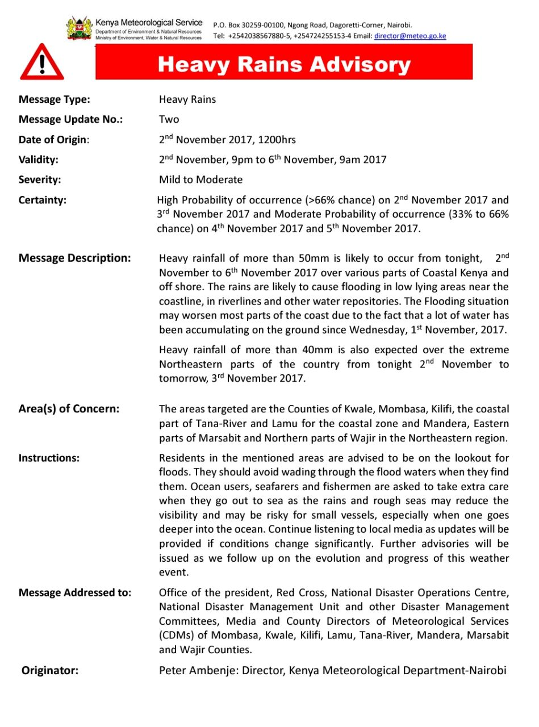
Figure 3: An example of heavy rainfall warning issued using the CAP system
Flood forecasts in KMD are developed specifically for the Nzoia River Basin, by the Flood Diagnostics and Forecasting Centre (FDFC) at KMD Headquarters in Nairobi. Work has been supported by the Western Kenya Community Driven Development and Flood Mitigation Project within the then Ministry of State for Special Programmes in the Office of the President, and funded by the World Bank.
Areal forecasts for water levels in the basin are generated based on data from hydromet, rainfall and river gauge stations. As shown in Figure 4, water level thresholds have been set to indicate flood alert (amber) at 4m and flood warning (red) at 5m as the water approaches the river dyke level that is set at almost 6m. The information is presented as deterministic forecast for water levels at Rwambwa Bridge River Gauge Station. The observed areal rainfall and daily rainfall forecasts for the basin are also presented.
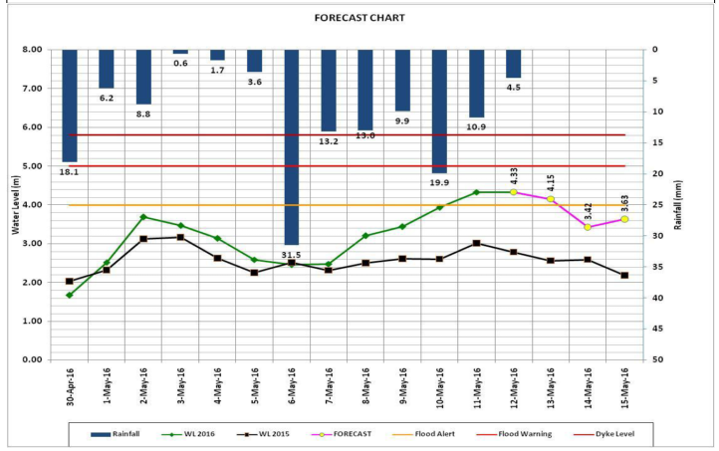
Figure 4: Flood forecast chart for Nzoia River Basin, for May 2016. A flood alert was issued on 10th May 2016 when the water levels crossed the 4m threshold, following four consecutive days of rainfall. The flood model then indicated water levels to subside to below 4m by 14th May 2016. Source: KMD presentation at ForPAc Inception Workshop, September 2017.
Flood forecasts generated by KMD are part of a localised flood EWS as presented in Figure 5. The flood warnings are issued in form of flood watch bulletins that show the rainfall patterns and forecast over Nzoia River Basin, observed and forecasted water levels and the flood risk. The bulletins are widely distributed electronically, through community radio (Bulala RANET FM) in local languages and in print to various stakeholders, including the County Disaster Managers, government departments and humanitarian agencies to help them make informed decisions on flood disaster preparedness and response. The EWS has led to a reduction in the proportion of households affected by floods in the Nzoia River floodplains to 5% from a baseline value of 25% (World Bank, 2016).

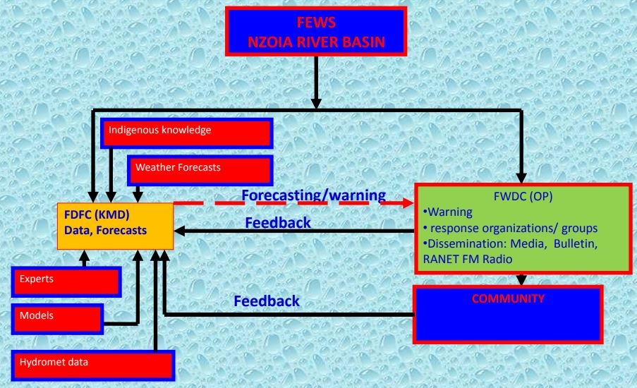
Figure 5: The flood EWS for Nzoia River Basin
    - What does forecast decision making in KMD look like?
KMD is a National Government institution, under the State Department of Environment in the National Ministry of Environment and Natural Resources. Budget allocations for operations at KMD therefore come from the National Ministry.
KMD is headed by the Director, with support from 4 specialised Deputy Directors, as shown by Figure 6. In line with devolution of government in Kenya, KMD decentralised its services to the county level through designated County Meteorological Offices (CMO), run by County Directors of Meteorology (CDM). Key roles of the CMO and CDM in relation to EWS include (KMD & UKMO, 2015):
- Develop and disseminate weather and climate products and services (including forecasts, warnings, alerts etc. for county government, the public and climate sensitive sectors);
- Downscale national seasonal weather forecasts and climate outlook;
- Enhance the understanding and effective use of weather and climate information at the county level and in the development agenda;
- Stakeholder engagement with the county government and organisations based in the county, identifying opportunities for collaboration;
- Ensure monitoring, acquisition, collation and transmission of data on weather, climate, water and related environmental information at the county level;
- Recruitment and training of intermediaries and Community Climate Observers.

Figure 6: KMD organisational structure
All forecasts are generated by the National Meteorological Centre (NMC) in Nairobi. Daily conferences are held at NMC to discuss forecasts developed by duty meteorologists and to get expert input into the forecast before it is ready for dissemination.
All national early warning forecast information is approved and issued by the Director KMD. Figure 7 presents the flow of early information from KMD to various stakeholders, including the Office of the President and the CMO (Ochieng, 2014). At the county level, CDMs can issue forecasts for their particular counties.
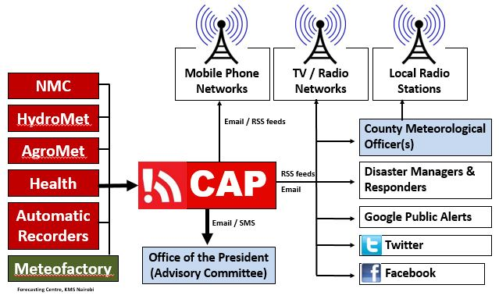
Figure 7: Flow of early warning information through CAP. Source: Presentation on CAP Implementation in Kenya, 2014.
    - Emerging issues for KMD early warning information related to FbA
With consideration of FbA, key things to note about forecast early warning information from KMD:
- Presentation of the national forecast is sub-divided into 6 regions. This makes the information most useful for national level actors. County forecasts are developed, mostly focussing on daily to 7-day and seasonal forecasts. Seasonal forecasts in particular are downscaled from the national forecasts. Downscaling to county level is based on the probabilities presented in the national forecasts and results in expected rainfall amounts in a county. This then moves from a probabilistic to a deterministic seasonal forecast, aimed at improving understanding of and therefore action in response to a county seasonal forecast. It is, however, important to recognise that the accuracy of the downscaled county seasonal forecast is affected by the accuracy of the national forecast.
- At the end of the 5-day to seasonal forecasts, it is indicated that the forecast should be used in conjunction with the daily, five-day, weekly and monthly forecasts including updates, advisories and alerts issued by KMD. This points users to the need for continuous monitoring of forecast information provided, with an opportunity to update the certainty and reliability of an earlier forecast.
- Lead times of the forecasts can be from a few hours (e.g. heavy rainfall warning in Figure 3), a day (e.g. monthly forecast for December 2017 was issued on 29th November 2017) to 1 month (e.g. seasonal forecast for the October – November – December (OND) 2017 rainfall season was issued on 29th August 2017) ahead. As highlighted by (Habilov, et al., 2015), how ‘early’ the forecasts need to be to be useful for decision making is different for different stakeholders. Timeliness also depends on the different types of actions and the related decision making and operational procedures needed to make the actions happen. Useful lead times of forecast information therefore need to be defined together with targeted users.
- Reliability of forecasts is not presented in KMD forecasts available online and released to various other media channels.
  - The National Drought Management Authority
NDMA is the Kenya Government institution mandated to provide leadership and coordinate drought risk management plans, interventions, polices and stakeholders across national and county levels. The NDMA Act of 2016 (GoK, 2016) states that the functions of the Authority (see Box 1) include development and operation of a drought early warning system (DEWS), and the establishment of drought preparedness strategies and contingency plans. Though it is a national institution, NDMA focusses its work and operation of the related DEWS in the 23 ASAL counties in the country. ForPAc’s case study areas of Isiolo County and Kitui County fall in the arid and semi-arid areas respectively.
Box 1: Functions of NDMA
Section 5 of the NDMA ACT 2016 describe the functions of the Authority shall be to:
- exercise overall coordination over all matters relating to drought management including implementation of policies and programmes relating to drought management;
- coordinate drought response initiatives being undertaken by other bodies, institutions and agencies;
- promote the integration of drought response efforts into development policies, plans, programmes and projects in order to ensure the proper management of drought;
- develop, in consultation with stakeholders, an efficient, drought early warning system and operate the system;
- facilitate national and county level drought contingency processes and the preparation of national and county level drought contingency plans;
- establish and review, in consultation with stakeholders and relevant institutions and agencies, drought preparedness strategies;
- identify, design and implement projects and programmes that shall strengthen resilience to drought and climate change;
- publish and disseminate manuals, codes or guidelines relating to drought management and prevention or abatement of the extreme effects of drought on human, plant and animal life;
- conduct research on drought management and generate, consolidate and disseminate drought management information;
- render advice and technical support to persons, bodies or institutions engaged in drought management so as to enable them to carry out their responsibilities effectively;
- coordinate with the national government where a drought situation requires the declaration of a national or international disaster;
- coordinate the design and implementation of the country's regional and international commitments pertaining to drought management;
- prepare and issue an annual report on the state of drought management in Kenya; and
- perform such other functions as are incidental or conducive to the exercise, by the Authority, of any or all of the functions provided for under this Act.
    - NDMA DEWS indicators, thresholds and early warning information
Indicators monitored by the DEWS are categorized into four types: biophysical, production, access and utilisation indicators, as presented in Table 4.
Table 4: Indicators monitored by the NDMA drought EWS (Source: NDMA)
Type of indicator | Examples of indicators monitored | Data sources | Types of impact
Biophysical | - Rainfall estimates  - Vegetation Condition Index (VCI)  - State of natural vegetation and pasture conditions  - State of water sources | - WFP-VAM, CHIRPS UCSB  - Satellite data from MODIS | Environmental
Production | - Livestock production –Livestock body condition, livestock diseases and pests, milk production, livestock migration patterns, livestock mortality  - Crop production – Timeliness and status of crops, implication on food security | - Observed field conditions  - Key informant interviews  - Household surveys  - Reviewed secondary data | Livestock production  Crop production
Access | - Livestock Prices - Terms of trade, cattle/ goat prices  - Price of cereals and other food products  - Distance to water for households  - Distance to grazing areas | - Observed field conditions  - Key informant interviews  - Household surveys  - Reviewed secondary data | Markets  Access to food & water
Utilisation | - Health and Nutrition Status – Mid-Upper Arm Circumference (MUAC), human diseases and epidemics  - Coping strategy index  - Milk and food consumption | - Nutrition data from Ministry of Health  - Observed field conditions  - Key informant interviews | Nutrition  Coping strategies
Biophysical indicators monitor the nature of drought hazard with consideration of:
- Meteorological drought – using rainfall estimates,
- Agricultural drought – using 3-month average of VCI (see example in Figure 8), and
- Hydrological drought – by monitoring the state of water sources and water availability.
Figure 8: Isiolo was in Severe Vegetation deficit band within thresholds of 16.44 implying a persistent prevalence of poor vegetation condition across all livelihood zones. The poor vegetation condition is attributed to the depressed rainfall of two consecutive seasons OND 2016 and MAM 2017 (NDMA, 2017).
Production, utility and access indicators monitor the impacts of the drought. These indicators take into account the main livelihoods in the ASAL counties – pastoralism and agro-pastoralism with minimal crop farming – whose development and implementation has a direct relation with the status of food security. Specifically, the Coping Strategy Index (CSI) as a utility indicator measures behaviour: the things that people do when they cannot access enough food. CSI considers the frequency of the coping strategies used and the severity of the strategies with regard to what degree of food insecurity do the strategies suggest. Only the coping strategies that are important in a particular local context are considered (Maxwell & Caldwell, 2008), taking it back to the focus on local livelihoods.
The indicators provide a retrospective analysis of observed conditions, in order to calculate deviations from long term averages as droughts emerge. Figure 9 presents an example of this analysis for milk production in Kitui County, between January and September 2017, compared to the average milk production in 2011 to 2016.
Figure 9: Retrospective analysis of milk production up to September 2017 in Kitui County (NDMA, 2017).
Thresholds have been set for particular indicators to define the state of impacts monitores. For example, in Figure 8, 3-month VCI values of 35 to 50 indicate that vegetation greenness is in a normal state for that period of time, while values of 10 to 20 show a severe vegetation deficit.
Observed thresholds for the different indicators are put together to determine the severity of the drought and therefore classify a given area in to a particular phase. Five drought phases have been defined as normal, alert, alarm, emergency and recovery (Figure 10). An example of the range of indicator threshold values for each phase is presented in Table 5.
Table 5: An example of indicator threshold values for different drought phases in Baringo County (Source: NDMA)
Indicator | Baseline: | Threshold and trigger level
Wind direction | - Wind direction is normally easterly | Wind direction changes North(alarm)
Distance to watering point | - Less than 2Km for households | Distance to HH water point | Alert | Alarm | Emergency
Distance to watering point | - Less than 2Km for households | Distance to HH water point | 10-15 | 15-20 | >20 Km
Distance to pasture | - 3 - 12Km for livestock | Distance to pasture | Alert | Alarm | Emergency
Distance to pasture | - 3 - 12Km for livestock | Distance to pasture | 15-18 | 18-22 | >70
Price of food commodities |  | Commodity | Alert | Alarm | Emergency
Price of food commodities | - Maize: Ksh. 30 | Maize | 35 | 40 | 50
Price of food commodities | - Beans: Ksh. 40 | Beans | 60 | 80 | 100
Price of food commodities | - Milk: Ksh. 10 - 15 | Milk | 20 | 25 | 30
Livestock price |  | Livestock | Alert | Alarm | Emergency
Livestock price | - Goat: Ksh.5000 | Goat | 4,000 | 3,000 | 2,000
Livestock price | - Cattle: Ksh. 28,000 | Cattle | 20,000 | 15,000 | 10,000
Livestock price | - Camel: Ksh. 62,000 | Camel | 50,000 | 30,000 | 20,000
Malnutrition status among children | - MUAC reading is within green areas | Malnutrition  Status among children | Alert | Alarm | Emergency
Malnutrition status among children | - MUAC reading is within green areas | Malnutrition  Status among children | Yellow | orange | Red
Figure 10 further shows that biophysical indicators monitoring environmental impact form the basis for determining the drought phase classification. Fluctuations in indicators that monitor production, access and utilisation of food are observed in the alarm and emergency phases, following deviation in biophysical indicators.
The drought phases are matched to the stages in drought cycle management so as to define the broad types of actions to be taken at the different phases (Figure 11). Drought preparedness is expected to be carried out during the normal phase, when no unusual fluctuations have been observed in all the indicators. This implies that drought preparedness needs to be part of regular livelihoods and development interventions, rather than only carried out when the occurrence of drought is imminent or ongoing.
Figure 10: NDMA drought phase classification | 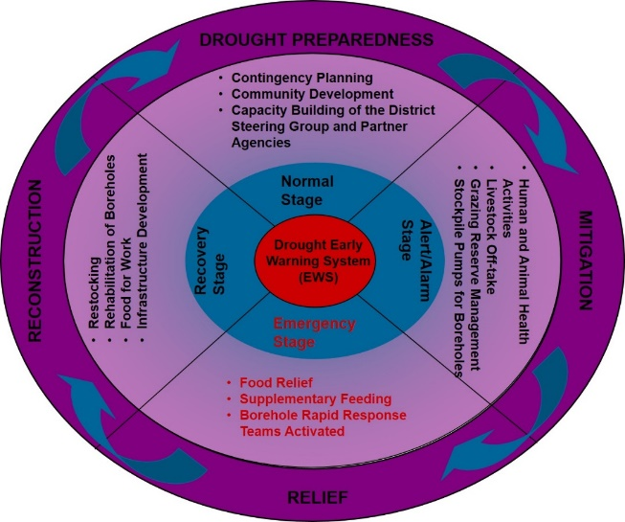  Figure 11: Drought Cycle Management in NDMA
The drought indicators and phases are monitored in all the 23 counties on a monthly basis. Trends in the phases are determined and presented using the terms “improving”, “stable” and “worsening”. It is not clear if determination of trend is based on objective (i.e. based on some calculation including from using weather and climate forecasts) or subjective considerations.
    - What does the NDMA system and decision making look like?
The drought management system has five components (GoK, 2013):
- a national drought management policy
- a drought early warning [information] system
- a set of county level contingency (‘shelf’) plans
- a drought contingency (response) fund
- drought coordination and response structures
This system is described below.
- National drought management policy
The guiding documents for the NDMA are the Constitution of Kenya 2010 (which places a duty on the state to protect the vulnerable), Sessional Paper No. 8 of 2012 on the National Policy for the Sustainable Development of Northern Kenya and other Arid Lands (the ‘ASAL policy’), and the Ending Drought Emergencies Medium Term Plan. A specific policy on drought management in the country has not been developed (GoK, 2013).
- Drought early warning information system
Field monitors collect data on production, access and utilisation indicators in a total of 154 sentinel sites in all 23 ASAL counties. In each site, data is collected from 30 households and between three to five key informant and community surveys. Data is also sourced from key sectors involved in food security and drought management. The key sectors are: Agriculture, Livestock, Water, Education, Health and conflict and peace building.
The data collected is analysed in the NDMA county office, by County Drought Coordinators and County Information Managers. The analysis is then compiled into a monthly drought early warning bulletin.
As established by Section 7 of the NDMA ACT 2016, the County Steering Group (CSG) is tasked to coordinate and oversee drought related interventions in all drought prone counties. The early warning bulletins are therefore shared with the CSG for discussion, validation and approval. The bulletins are distributed to state and non-state actors in the county, so as to inform drought management plans and activities.
The county level reports are then compiled by the NDMA National Office to form a national drought early warning bulletin. Details of the information system are presented in Figure 12.
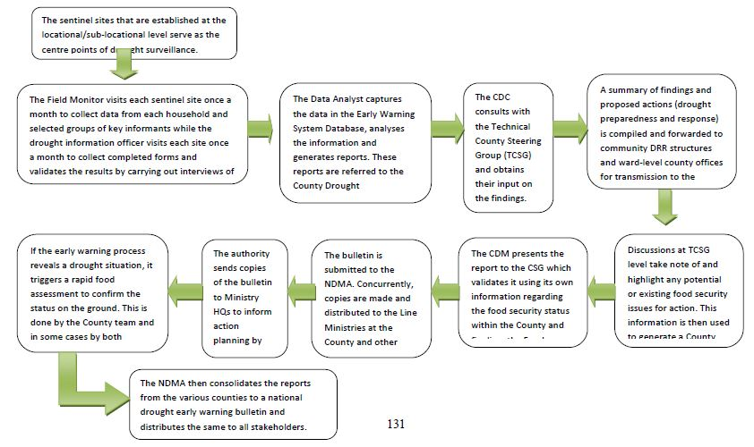
Figure 12: Drought early warning information system. Source: Garissa Contingency Plan, 2014
- County contingency (‘shelf’) plans
A federation of community-level planning units at ward level carry out participatory disaster risk assessments, leading to the formulation of local drought response plans. This is meant to enhance local preparedness to respond to droughts and other disasters (Luigi, 2011).
Ward level plans are reviewed and consolidated at sub-county level. At county level, NDMA facilitates a multi-stakeholder contingency planning process. The process considers impact scenarios of projected drought risks. A comprehensive and costed action plan that responds to each of these scenarios is then put together. Standard Operation Procedures (SOPs) are developed that define actors, taskforces/ working groups and their roles in actions before, during and after a drought (NDMA, 2014).
The contingency plan is presented to the CSG for approval, and then sent to the National NDMA Office for consolidation into a national drought contingency plan. Projected drought management funding requirements are also consolidated for inclusion in the national budget. A detailed summary of the drought contingency planning process is presented in Figure 13.
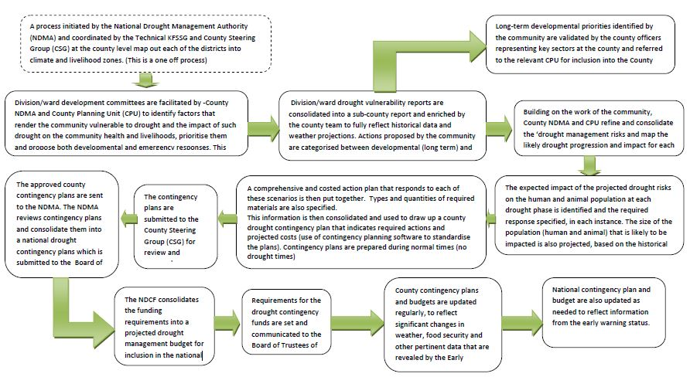
Figure 13: Drought contingency planning process. Source: Garissa Contingency Plan, 2014
- Drought contingency (response) fund
Section 18 of the NDMA ACT 2016 establishes the National Drought Contingency Fund (NDCF). The objective of the Fund is to:
- facilitate timely response to drought during its different phases;
- provide a common basket of emergency funds, with contributions from state and non-state actors;
- provide funds for capacity and technical expertise development to improve on drought management; and
- finance the establishment, management and coordination of projects, activities or programmes targeted at drought management.
The criteria for release of contingency funds is structured to be systematic, evidence-based and linked to the drought management cycle. When a drought early warning bulletin indicates an imminent or worsening drought situation, a rapid food security assessment is triggered to verify the situation on the ground. Based on the assessment, an implementation plan is triggered, informed by the county’s contingency plan. The assessment also triggers requisition of finance from the NDCF, based on the costed activities in the contingency plan. The Fund is therefore aimed at ensuring implementation of contingency plans is fast-tracked to respond to emerging drought stress (Kenya Ministry of Devolution and Planning, 2013). The NDCF will ensure that action in the early stages of a drought, when its effects can best be mitigated, is more timely, flexible and appropriate, triggered by information generated through the EWS (GoK, 2013). This implies that the NDCF aims to fund not just drought response actions but also drought preparedness actions.
Figure 14 presents the model used to trigger contingency plans and associated contingency funds.
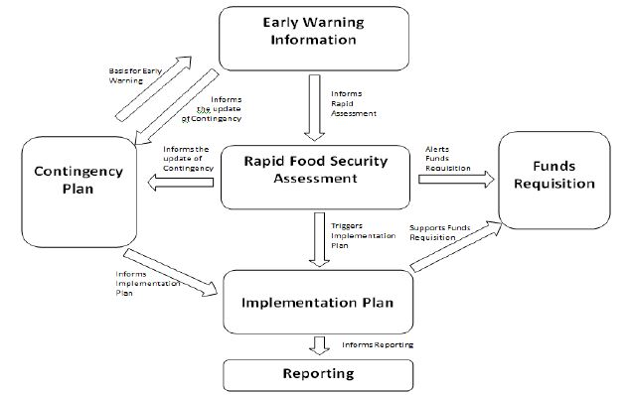
Figure 14: Drought contingency plan and funds requisition model. Source: Garissa contingency plan, 2014
- Drought coordination and response structures
Coordination of drought processes and interventions at county level is done by the CSG, with the NDMA County Office as the Secretariat. The NDMA County Office provides linkage to actors and structures at county, sub-county and community level, as well as to the National NDMA Office (Figure 15). The CSG links the county drought management process to the Kenya Food Security Steering Group (KFSSG) that is brought together during the Kenya Food Security Meeting (KFSM).
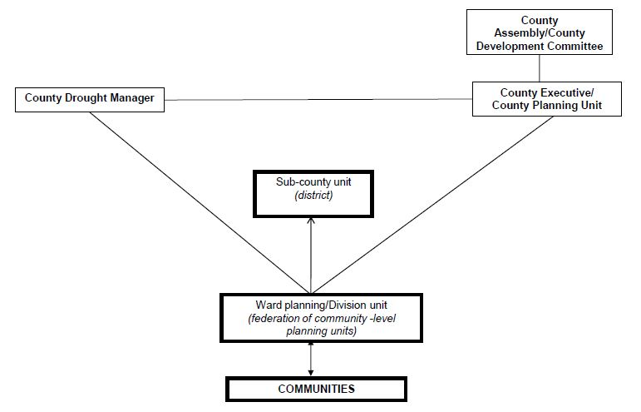
Figure 15: Drought management structures. Adapted from Garissa County Contingency Plan, 2015
    - Emerging issues for NDMA EWS related to FbA
Revision of the drought early warning system: Though it has been in place for many years, work under the EDE Common Programme Framework for Drought Risk Management (July 2014 – June 2018) plans to review and strengthen the DEWS, to ensure that early warning information is objective and relevant to the provision of early response. It means developing a rigorous system for assigning drought phases based on convergence of evidence from the different indicators. Revision may therefore be required on (NDMA, 2014):
- Number and choice of indicators – for example, while RFE is good estimate of rainfall in lowland areas, it does not work well in hilly areas. VCI may be a relatively good estimate of change in vegetation in arid counties, but in semi-arid counties, crop modelling is also needed;
- Thresholds for individual indicators need to be specific for each county so as to properly determine the drought phase;
- Selection of sentinel sites, to ensure a cost-effective system which takes account of changing livelihood patterns;
- Use of new technologies to gather, analyse and communicate data;
- Approaches and tools used for communicating early warning information to multiple audiences, including communities.
Credibility of the drought early warning system: Some of the ASAL counties face chronic food insecurity even when the drought early warning system registers a ‘normal’ status. This is due to underlying causes of vulnerability such as development marginalization, ineffective policy implementation and socio-cultural issues such as gender exclusion in decision making. As the drought management system is not designed to address the wider problem of underlying causes of vulnerability, there can be pressure from local leaders or the media overstating the severity of a drought. This in turn undermines the credibility and legitimacy of the early warning system, and by extension the NDMA, while also compromising the quality of response. County government involvement in, and ownership of, food security assessments and the early warning system, including triggers for response action, may mitigate the risks linked to local political influence (NDMA, 2014).
  - The Famine Early Warning Network (FEWS NET)
FEWS NET aims to provide evidence-based analysis and projections on food security to help government decision-makers and relief agencies to mitigate food insecurity as well as plan for and respond to humanitarian crises. Its operations cover all the countries in the Greater Horn of Africa.
The food security analysis is grounded in a deep understanding of the livelihood patterns and options available to households. It looks at how households cope with a food security ‘shock’ or ‘hazard’, such as a drought, flood, market disruption, or conflict. For example, how would rainfall failure affect pastoralists who have exhausted their own food stocks?
Livelihood zoning of Kenya was done in 2010 by FEWS NET, Food and Agriculture Organization (FAO), NDMA and World Food Program (WFP), based on secondary data reviews and workshops. The livelihood map developed (see Figure 16) defined 24 livelihood zones and is useful for deciding on areas to be sampled during food security assessments, such as conducted by NDMA. Livelihood descriptions that go with the map provide a geographical context for interpreting indicators monitored in order to identify potential problems or frames underlying the data (FEWS NET, 2011).
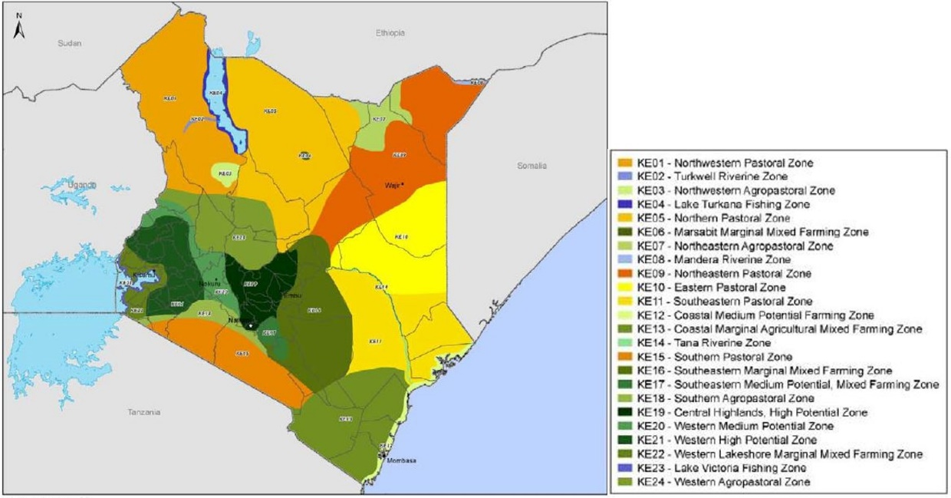
Key – livelihoods zoning in Kenya
Figure 16: Kenya generalised livelihoods zones. Source (FEWS NET, 2011)
From the Kenya livelihood map in Figure 16, ForPAc case study areas lie in the following livelihood zones:
- Isiolo County – 5 Northern Pastoral Zone, 9 North-eastern Pastoral Zone and 10 Eastern Pastoral Zone.
- Kitui County – 13 Coastal Marginal Agricultural Mixed Farming Zone, and 16 South-eastern Marginal Mixed Farming Zone
- Nairobi –19 Central Highlands, High Potential Zone
- Nzoia River Basin – 1 North-western Pastoral Zone, 20 Western Medium Potential Zone, 21 Western High Potential Zone, 22 Western Lakeshore Marginal Mixed Farming Zone, and 23 Lake Victoria Fishing Zone.
    - FEWS NET indicators, thresholds and early warning information
Indicators monitored by FEWS NET (Table 6) are used to analyse food security in terms of (FEWS NET, 2013):
- Availability – physical existence of food, from a household’s own production or from markets, including commercial food imports and food aid;
- Access – household’s ability to obtain foods for a nutritious diet though a combination of production, purchase, gifts, and transfers;
- Utilization – how well individuals utilize the food they access, including sufficient energy and nutrient intake and the ability to absorb nutrients;
- Stability – captures the level of uncertainty and vulnerability to future weather- and climate-related disruptions in food supply and household income.
Table 6: Indictors in the FEWS NET EWS
Indicator | What is monitored | Data sources | Type of impact
Livelihoods | - Livelihood strategies  - Coping strategies  - Household income | - Information collected by various national, regional and international partners e.g. USGS, USDA, National ministries of agriculture etc.  - FEWS NET national office –locally based fulltime analyst | Livelihood strategies that enable food access, availability and utilisation
Agricultural production | - Crops conditions  - Livestock conditions  - Pasture, water | - Information collected by various national, regional and international partners e.g. USGS, USDA, National ministries of agriculture etc.  - FEWS NET national office –locally based fulltime analyst | Availability and access to food and household income
Health and Nutrition | - Malnutrition rates in children  - Food consumption | - Small- and large-scale nutrition surveys  - FEWS NET national office –locally based fulltime analyst | Utilization of food
Markets and Trade | - Local staple food availability  - Prices  - Regional trade flows  - Macroeconomic drivers and shocks | - National ministries of agriculture  - Statistical offices  - Market information systems  - FAO  - WFP, and others.  - In a handful of countries, FEWS NET has teams of market monitors who collect data | Availability, access and stability of food supply
Weather Hazards | - Rainfall patterns  - Land surface temperatures patterns  - Normalized Difference Vegetation Index (NDVI)  - Severe weather or climate events  - Short and medium range weather forecasts (up to one week) | - FEWSNET/ USGS CHIRPS  - NOAA Climate Prediction Center Data Portal  - NASA  - Climate Hazard Group (CHG) Portal  - FEWS NET national office –locally based fulltime analyst | Stability of food, access and availability
Integrated Food Security Phase Classification in FEWS NET
IPC is a framework that provides common standards, language, and protocols for classifying the nature and severity of food insecurity in an area, based on the status of observed indicators. It aims at communicating actionable knowledge that is based on analysis of the existing situation and information required by decision-makers, so as to provide the most reliable, consistent and accessible information for decision making (IPC Global Partners, 2012).
Food security classification in IPC follows a five-phase scale (see Table 7). IPC reference tables are used to define key characteristics and thresholds of the different phases. Hazards, such as climate events, are considered as characteristics that define phase 1 and 2, and not phase 3 to 5, indicating consideration of hazards as an underlying factor in determining food security. Probability and severity of hazards, and vulnerability, are also used to explain the risk of worsening phase, as presented in Figure 17.
Table 7: Food security phase classification used in IPC and FEWS NET
Phase | General IPC description | FEWS NET description
1 | Generally Food Secure  Usually adequate and stable food access with moderate to low risk of sliding into phase 3, 4 or 5. | Minimal  More than four in five households (HHs) are able to meet essential food and non-food needs without engaging in atypical, unsustainable strategies to access food and income.
2 | Moderately/ Borderline Food Insecure  Borderline adequate food access with recurrent high risk (due to probable hazard events and high vulnerability) of sliding into phase 3, 4 or 5. | Stressed  Even with any humanitarian assistance at least one in five HHs in the area have the following or worse: Minimally adequate food consumption but are unable to afford some essential non-food expenditures without engaging in irreversible coping strategies.
3 | Acute Food and Livelihood Crisis  Highly stressed and critical lack of food access with high and above usual malnutrition and accelerated depletion of livelihood assets that if continued, will slide the population into phase 4 or 5 and/ or likely result in chronic poverty. | Crisis  Even with any humanitarian assistance at least one in five HHs in the area have the following or worse: food consumption gaps with high or above usual acute malnutrition OR are marginally able to meet minimum food needs only, with accelerated depletion of livelihood assets that will lead to food consumption gaps. | URGENT ACTION REQUIRED  !  Phase classification would likely be worse without current or programmed humanitarian assistance.
4 | Humanitarian Emergency  Severe lack of food access with excess mortality, very high and increasing malnutrition and irreversible livelihood asset stripping. | Emergency  Even with any humanitarian assistance at least one in five HHs in the area have the following or worse: large food consumption gaps resulting in very high acute malnutrition and excess mortality OR extreme loss of livelihood assets that will lead to food consumption gaps in the short term.
5 | Famine/ Humanitarian Catastrophe  Extreme social upheaval with complete lack of food access and/ or other basic needs where mass starvation, death and displacement are evident. | Famine  Even with any humanitarian assistance at least one in five HHs in the area have an extreme lack of food and other basic needs where starvation, death and destitution are evident. Evidence for all three criteria (food consumption, acute malnutrition and mortality) is required to classify Famine.

Figure 17: Risk of phase worsening, as defined in IPC
Guided by a key principle of consensus building, IPC classification follows a consultative process involving a team of expert analysts. The analysts make subjective interpretation of accumulated evidence from multiple indicators and sources. They also assign heuristic reliability scores to each data source that contributes to the classifications, and assign a confidence level to the final phase classification (Jones, Ngure, Pelto, & Young, 2013).
Since March 2011, FEWS NET has used the IPC Version 2.0 to analyse and classify food insecurity. The analysis is ‘IPC Compatible’, meeting the following minimum protocols:
- The IPC Reference Tables are used to determine the Phase classification.
- The analysis adheres to key parameters of units of analysis and accounting for humanitarian assistance.
- Evidence used to support the classification is clearly documented and made available.
- The analysis is mapped using the IPC colour scheme and Phase names.
FEWS NET food security situation analysis and classification however does not necessarily reflect the working consensus of national food security partners (FEWS NET, May 2017), which is one of the key protocols in developing an ‘IPC Product’. However, because the analysis largely adheres to IPC protocols, the results can be compared, questioned and built upon across countries and regions, and over time, as influenced by various factors including climate (IPC Global Partners, 2012).
    - What does the FEWS NET system and decision making look like?
Scenario development
Scenario development is conducted every four months, using an eight-step process (see Figure 18).

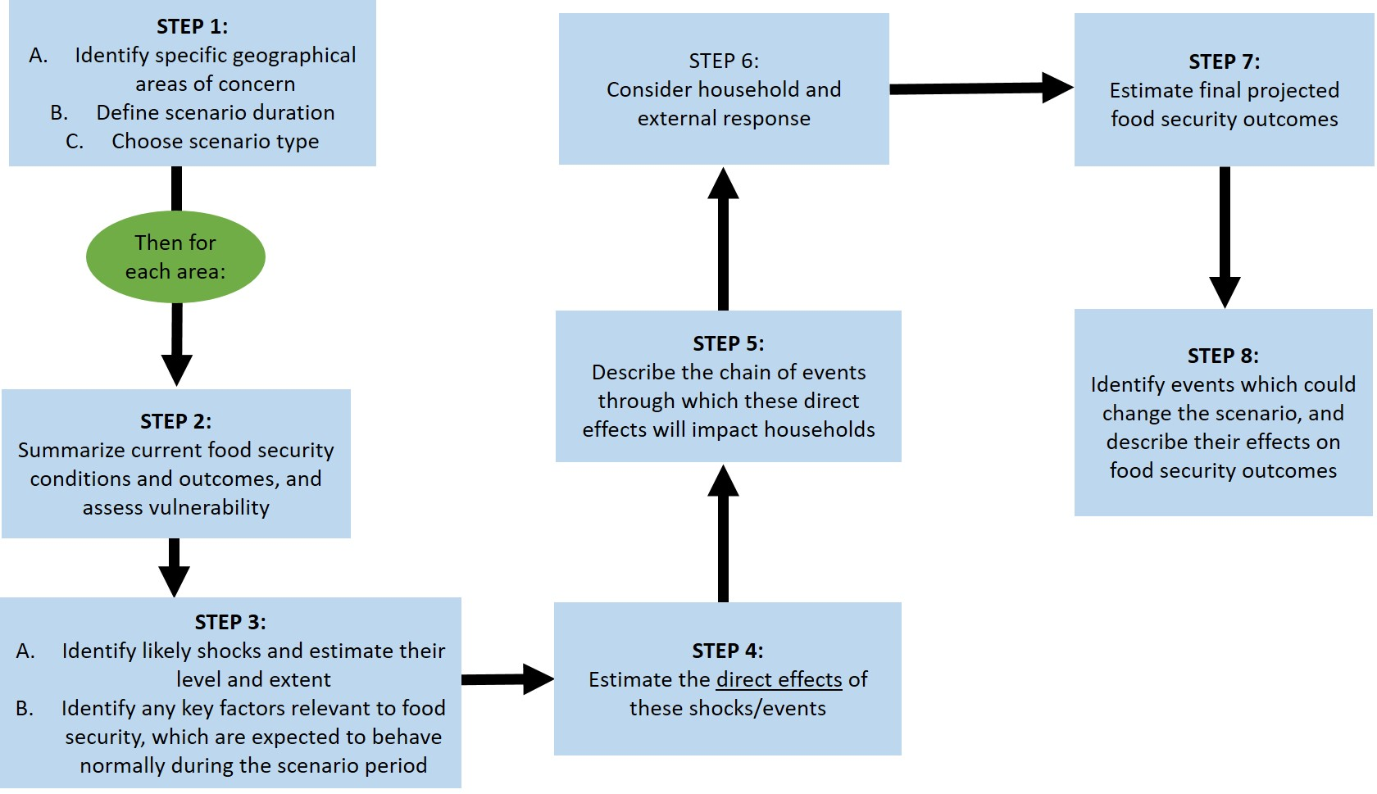
Figure 18: Scenario development process used by FEWS NET
The indicators monitored are used to assess the current food security situation in an area, and classify the situation using the Integrated Food Security Phase Classification (IPC) process (see Figure 19). A set of assumptions on how drivers of food security are likely to evolve in the future, their effects, and the probable responses of various actors are then made and assessed in the context of current conditions and local livelihoods.
Assumptions often need to be made about the timing, duration, and severity of the expected weather and climate shocks (Step 3 in Figure 18), and their effects on household food security (Step 4 in Figure 18). Climate forecasts are therefore potentially used in Step 3 and 4. Frequently, multiple shocks may be expected to occur during the scenario period. For example, a policy decision to stop input subsidies could occur shortly after poor rainfall is forecasted while conflict continues along a key trade border point (FEWS NET, 2010).
The assumptions are then used to develop projections of the most likely food insecurity scenario over four to eight months ahead (see Figure 20).
Figure 19: Current food security situation, October 2017 | Figure 20: Projected food security outcomes, October 2017 to January 2018
Events that might change the most likely scenario are also considered, key of these being weather and climate events. For example, the outlook for October 2017 to January 2018 considered that if less than 50% of average rainfall was received in the remainder of the short rains season, food security would deteriorate in the Northeastern pastoral areas (Isiolo County) and Southeastern marginal agricultural areas (Kitui County). This would potentially result in (FEWS NET, 2017):
- Below-average regeneration of forage and water resources and a decrease in livestock productivity, moving more households into Crisis (IPC Phase 3) and potentially some of the most vulnerable households into Emergency (IPC Phase 4) in the Northeastern pastoral areas,
- Coping capacities being eroded and likely increase the severity of acute food insecurity to Crisis (IPC Phase 3) in Southeastern marginal agricultural areas.
This projection agrees with the Dec 2017 NDMA bulletins that showed the drought situation in Isiolo County was in alarm phase while Kitui County was in alert phase, with the situation worsening in both counties. Below average rainfall and its early cessation (in Kitui) during the October to December (OND) 2017 short rains season contributed to the situation (NDMA, 2017).
Structure
FEWS NET is led by USAID, a US Government Institution. It draws technical expertise from the National Aeronautics and Space Administration (NASA), National Oceanic and Atmospheric Administration (NOAA), US Department of Agriculture (USDA) US Geological Survey (USGS) and Kimetrica. The network operates in East Africa, West Africa, Southern Africa and Latin America and the Caribbean Regions, where the level of food insecurity is high.
Each region has an in-house climate scientist, while meteorological technical support comes from NOAA. Technical Managers are in charge of food security monitoring and analysis in the region, working with FEWS NET Country Offices.
Because it is a ‘network’, FEWS NET engages with national government ministries and agencies such as NDMA, international agencies including in the UN system, and NGOs who collaborate in data collection and analysis. The same institutions also use the information generated.
  - Mapping existing EWS in Kenya to a people-centred approach (FbA)
An effective early warning system needs to understand the risk context for which it is issuing a warning, monitor and forecast the relevant risk metrics, develop and send out the appropriate communication and engage with the relevant decision processes and trigger action. This essentially means that an early warning system is most effective when it is people-centred, empowering stakeholders threatened by hazards to act in sufficient time and in an appropriate manner to avoid or reduce risk. A people-centred early warning systems is composed of four inter-related elements (UNISDR, 2006):
- Risk Knowledge – generated from the combination of hazards and vulnerabilities at a particular location. Assessments of risk require systematic collection and analysis of data and should consider the dynamic nature of hazards and vulnerabilities.
- Monitoring and Warning Service – with a sound scientific basis for predicting and forecasting hazards and a reliable and accurate forecasting and warning system.
- Dissemination and Communication – of warnings must reach those at risk. Clear messages containing useable information are critical to enable proper responses that will help safeguard lives, livelihoods and development.
- Response Capability – is essential to appropriate action to early warning. This requires a clear understanding of risks, know how to react and all forms of capacity required to take action.
The KMD forecasts, NDMA DEWS and FEWS NET EWS – as described in the sections above – are mapped against the four elements of a people-centred EWS, considering key questions raised by each element. This is presented in Table 8 below.
Table 8: Mapping the EWS against a people-centred approach
Risk Knowledge – Are the hazards and vulnerabilities well known? What are the patterns and trends?  NDMA and FEWSNET EWS continuously monitor drought hazard and socio-economic drivers of food insecurity. These provide information on current vulnerability in particular locations.  KMD historical climate data provides information on the occurrence of droughts and flood hazards over time. This can provide some information on the severity of a past flood or drought in meteorological terms.  All the systems have the potential to bring out the evolving patterns of hazards and vulnerability, and when put together, to define patterns of climate risk.  However, it is not evident how the historical data and information from the three systems are combined in a regular assessment of risk. This implies that climate risk knowledge may be limited. | Monitoring and Warning Service – Are the right parameters being monitored? Can accurate and timely warnings be generated?  The question on if the right parameters are being monitored, as well as forecasted and presented still needs to be asked.  NDMA and FEWS NET EWS use similar indicators to monitor drought and food security. Assessments are needed to find out how consistent these indicators are with the understanding of drought and food security, as well as the indicators’ precision, dependability and accuracy in measuring the hazard and outcomes (Jones, Ngure, Pelto, & Young, 2013). This will also inform the accuracy of drought trends developed by NDMA and the food security projections developed by FEWS NET.  A similar assessment on indicators’ precision, dependability and accuracy is needed for forecasts generated by KMD, especially in relation to how well they forecast droughts and floods, and the confidence level of such forecasts.
Dissemination and Communication – Do warnings reach all of those at risk? Is the warning information clear and usable?  All the 3 EWS have an emphasis on communicating information through their institutional website. NDMA also communicates though the CSG meetings. While this matches with the recognition that early warning information must come from an authoritative source, the communication channels used are better targeted at organisations and institutions and may not reach at risk communities. The early warning communication needs to be better customized to recognise the diversity of the audience and be appropriate to that audience (IFRC, Save the Children, Oxfam, FAO, WFP, 2014). Further, the information should relate to the evolving risks and therefore decision making needs. | Response Capability – Are local capacities and knowledge made use of? Are people prepared and ready to act to warnings?  The three EWS have defined thresholds for issuing particular types of warnings. However, it is yet unclear how the set thresholds are related to stakeholders’ thresholds for preparedness decision making and action. Further, thresholds for action should also be relevant to stakeholders’ capacity to take action.  The institutional and decision making context in which an EWS is located determines how information is used and by whom. Key factors include ownership of the EWS and the extent to which it is embedded within a wider decision making system and operational procedures (Bailey, 2013). Therefore, for action to be triggered, clear and accountable decision making structures, roles and responsibilities for early warning and early action at all levels should be in place (IFRC, Save the Children, Oxfam, FAO, WFP, 2014).
From Table 8, the three EWS match the four elements to some extent, but also raise issues where further work is needed. From an operational point of view, some elements of the people-centred approach are not yet mature. In particular, it is essential to strengthen the links between stakeholders involved in generating early warning and those in charge of responding to these warnings, as well as promoting good governance and appropriate preparedness and response action plans (UNEP, 2012).
- Regional EWS initiatives in the GHA
  - IGAD Integrated Regional Early Warning system (IREWS)
The IREWS is operated by the ICPAC, with support from UNDP, UNITAR, UNOSAT, ESRI, NOAA and FAO (ICPAC, 2015). The EWS covers the IGAD Region, giving early warning information on drought and floods.
Early warning information provided is retrospective with regard to drought risk, and with a lead time of up to 6 days ahead for flood risk.
Drought conditions are based on 10 – 30day monitoring of:
- Standardized Precipitation Index (SPI) that is calculated from a blend of regional rainfall observation data and CHIRPS data,
- Assessment of vegetation conditions using NDVI anomalies from the MODIS terra satellite, and
- Land cover types.
A combined drought index is presented, putting together SPI and Vegetation Health Index (VHI). Time lagged relationship between rainfall and NDVI is used to statistically model drought, especially in the rangelands.
Flood risk considers:
- 6 days forecast for areas with heavy rains, generated by the IRI
- Long term average rainfall (1981 – 2015)
- 10-day rainfall from TAMSAT satellite
- Delineated streams in catchment areas greater than 1,000km².
Daily rainfall and temperature are used to model water levels (using GeoSFM) in major rivers in the IGAD Region. Flood alerts are triggered based on water levels expected to be above a particular height.
  - Africa RiskView (ARV)
ARV is a modelling platform that is used to estimate the number of people who could potentially be affected by drought, based on retrospective observations and analysis. The associated costs of responding to a drought are estimated so as to trigger a corresponding insurance pay out. It is operated by the Africa Risk Capacity (ARC), a specialised Agency of the African Union. As of 2017, 32 African countries were signatories to the ARC Agency treaty, including Kenya (ARC, 2017).
Various satellite rainfall data sets, as selected by participating countries, are used to track the progression of a rainy seasons in Africa.
Water Requirements Satisfaction Index (WRSI) is used as an indicator for drought. WRSI estimates whether a particular crop is getting the amount of water (from rainfall) it needs at different stages of its development.
Based on WRSI calculations, the number of people that may be directly affected by drought in each country is estimated. This estimation uses vulnerability profiles developed by the signatory countries. According to the Kenya Drought Operations Plan 2013-14 that was submitted to the ARC Agency, the country’s vulnerability profile is based on Food Security Phase Classification between 2007 and 2011 and a livelihood zones map that was developed in 2010 (GoK, 2013). The profile is meant to define the potential impact of a drought on the population living in a specific area.
ARV converts the numbers of people potentially affected by drought into the costs of response to the drought, based on a pre-defined response cost per person.
Threshold costs for drought response are defined by countries in advance of a rainy season. When the estimated cost of response at the end of the season exceeds the pre-defined threshold, insurance pay outs are triggered. Further, ARV only triggers a payout in case of a major drought at the national scale.
All the parameters are customised to reflect a country’s realities on the ground.
A key lesson learnt from implementing ARC pay outs is the definition of thresholds for drought disasters. Threshold settings for drought in the ‘political narrative’ may be different from thresholds set within a country’s ARC operational plan. For example, in Senegal, Niger and Mauritania in 2014, ARC financing was triggered based on predefined parameters being met after a bad agricultural season, but this did not occur in a context where drought had been declared in the three countries (ARC, 2017).
  - Food Security and Nutrition Working Group (FSNWG)
The Food Security and Nutrition Working Group (FSNWG) is a coordinating platform for regional food security and nutrition issues in East and Central Africa. It brings together more than 80 organisations involved in Food and Nutrition Security work in the region, including regional and national governments, UN agencies, donors, NGOs, academic and research institutions and the private sector.
Due to governments’ continued engagement through the IGAD Drought Disaster Resilience and Sustainability Initiative (IDDRSI), FSNWG is chaired by the IGAD Executive Secretary and co-chaired by the FAO Regional Representative based in Nairobi, Kenya. The position of the chair is permanent while the co-chair may be rotated among member organisations.
FSNWG Members engage in joint collection and analysis of national and cross-border information on:
- Nutrition and human diseases
- Agriculture – crop conditions using GeoGLAM, potential crop production especially considering rainfall performance
- Livestock and pastoralism
- Market Analysis with a focus on prices and availability of staple foods in the various countries; projections of food prices are presented
- Climate observations in the previous month and forecast updates
- Refugees – numbers and spread across the region, and nutrition status
- Numbers of people requiring humanitarian assistance
- Early Warning Early Action – considering humanitarian funding received compared to the humanitarian funding need.
Partnership with FEWS NET helps to analyse information collected using IPC methodology, and produce regional and country level food security and nutrition:
- Situation analysis – using Monthly retrospective observations, and
- Response analysis – through consideration of projections of food insecurity for up to 6 months ahead, and climate forecasts up to 2 months ahead.
Main drivers of food insecurity are considered to define potential trends. These drivers include: performance of seasonal rainfall, food prices, conflict and security, macro-economic issues such as inflation and trade, pests and diseases. Droughts and floods are considered as relates to their impact on food security.
The information generated by FSNWG contributes to IDDRSI Priority Investment Areas on disaster risk management, preparedness and response, as well as coordination.
  - Global Information and Early Warning System on Food and Agriculture (GIEWS)
GIEWS monitors the condition of major food crops across the globe to assess production prospects in the different agricultural seasons. It is an information network composed of FAO staff, UN Agencies, various government institutions and NGOs.
The EWS provides early warning on impending food crises at country or regional level, with consideration of 3 month retrospective observations on drought. Indices and analysis used are:
- The Agricultural Stress Index System (ASIS) estimates the percentage of cropland areas affected by dry spells or drought during the crop growing season in a particular area. ASIS assess the severity (intensity, duration and spatial extent) of the agricultural drought, considering the specific major crops grown in an area. 10-day NDVI data from SPOT-VEGETATION satellite and land surface temperature from the METOP-AVHRR sensor at 1 km resolution are used to develop the index.
- VHI is used to describe the condition of forage for livestock in the rangelands. VHI is a composite of Vegetation condition index (VCI) which is a calculation that is based on NDVI observations and Temperature Condition Index (TCI). TCI is calculated using maximum and minimum temperature.
- Performance of a rainy season considering amounts received compared to the long term average, onset and cessation. This is then related to impacts on livestock conditions and productivity, and production of major crops in an area. E.g. due to late onset and erratic distribution of March – May 2017 rainfall, in April 2017, FAO estimated the aggregate cereal production in 2016 to be 3.7 million tonnes, 12% lower than in 2015 and 15% below the average of the previous five years.
- Food Price Monitoring and Analysis (FPMA) Tool monitors a range of commodity prices in various markets, at daily or monthly frequency. Information in the FPMA is sourced from existing data collection systems at national, regional and global level.
National food security assessment and IPC analysis and projections are used to describe the food security situation and outlook.
  - Emerging issues for regional EWS related to FbA
Lead time for early warning and early action: Most of data used in regional EWS relates to production (e.g. pasture coverage, water availability, germination rate) and consequences (e.g. nutrition status, actual crop yield, livestock status, water level). While these are near real time observations, the monitoring indicators often lag an actual weather or climate event. For example, NDVI as common indicator used to monitor crop and pasture productivity lags behind the occurrence of a rainfall event, as presented in Figure 21. (IFRC, Save the Children, Oxfam, FAO, WFP, 2014) suggest that these indicators may be too late to act as ‘early warning’ of a weather or climate event. Investigation is needed on if the current lead times for information provided by the regional EWS provide useful information for early action.
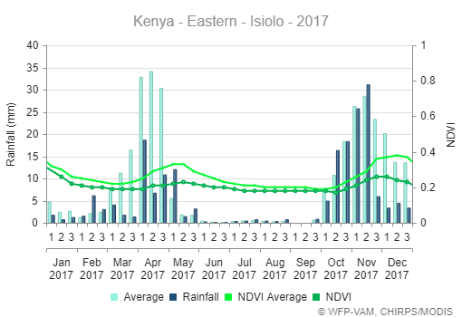 | 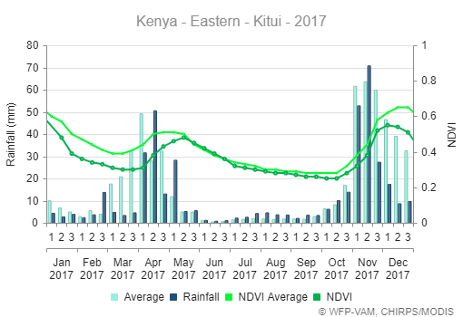
Figure 21: A plot of rainfall and NDVI values recorded in 2017 in Kitui and Isiolo Couties. In both counties, the peak in NDVI values is seen to occur sometime after the month that received most rains. This lag is more evident in the OND season, compared to the MAM season. Source: (WFP , 2018)
Defining combined indicator thresholds: Much like the existing EWS in Kenya, the regional EWS put together information from several indicators to come up with potential outcomes. For example, rainfall and NDVI are used to develop a drought index, WRSI and potential number of people affected by drought to estimate costs of drought response. This has the potential to develop an objective analysis. However, thresholds are not clearly defined for the overall combined indicators to determine the magnitude and severity of climate hazards and risk so as to trigger action.
Data used in the EWS: All the EWS rely on satellite derived data and information to develop various monitoring and forecasting indices. Actual observation data is only used in the IREWS (by merging rainfall station observations with CHIRPS data) and FSNWG (from data collected in county by member organisations). While satellite-based indices have the advantage of wider spatial coverage, there is a limitation of over or under estimation of rainfall and vegetation conditions by satellites. The indices work better in countries with semi-arid conditions where water stress is the main limiting factor of agriculture production. Composite information and indices used in most applications tend to limit these effects (Rojas & Ahmed).
Drought preparedness: There is a heavy focus on drought early warning compared to floods, in almost all EWS. Drought is a slow onset hazard and therefore more predictable because ‘you can see it coming’. For example, forecasts of the impending 2010/2011 drought crisis started in August 2010 and the predictions became more valid in early November 2010, when the OND rains were forecasted to be poor. In December 2010, FSNWG stated that “preemptive action is needed to protect livelihoods and avoid later costly lifesaving emergency interventions” and called on the humanitarian community “to be prepared now at country level.” However, the level of preparedness and timeliness of response to regional early warning was too slow. Responding on the basis of forecasts instead of hard observational data requires a shift in understanding, communicating and dealing with uncertainty (Oxfam and Save the Children, 2012). It also requires a culture of preparedness among stakeholders involved, especially across the different natural hazards (Development Initiatives, 2017).
- Relatively light touch political economy analysis in Kenya
Analysis of the political economy presents the key documents that guide policy, planning and operations on disaster risk management, the major institutions involved and coordination mechanisms. These are presented in Tables 9, 10 and 11 below.
  - Agenda setting documents for disaster risk management
Table 9: Key disaster risk management documents
Document | What it says about EWS and preparedness
Constitution of Kenya 2010 | The constitution provides for a declaration of a state of emergency, to meet the circumstances of threatening situations. The state of emergency is declared by president under Article 132 (4) (d), when state is under threat by massive disasters, including overwhelming fires, floods and droughts. The national assembly can extend the period the state of emergency if necessary, and supreme court establishes the legality of the declaration. The constitution also places a duty on the state to protect the vulnerable.
Vision 2030, Medium Term Plans, Sector Plan for Drought Risk Management and Ending Drought Emergencies (2013 – 2017) | Vision 2030 is the national development plan.  Early warning is mentioned in the plan as one of the key elements to drought preparedness and response. The existence of early warning information is noted but its effect on early response is observed as poor: droughts have been consequently tackled in a reactive manner instead of anticipatory and preventative. The system, which has been in existence for two decades, was in review to sharpen its technical aspect. An integrated drought early warning system is envisioned, whereby different systems used by different stakeholders will be stream lined into one.
Sessional Paper No. 8 of 2012 on the National Policy for the Sustainable Development of Northern Kenya and other Arid Lands (the ‘ASAL policy’) | NDMA is one of key specialist institutions listed in ASAL policy, and is designated to provide leadership in: collecting and communicating information to trigger specific government led activities at different stages of the drought cycle, in combination with the preparations made by communities. A key tool identified is the National Drought Contingency Fund - NDCF.
National Disaster Management Policy (draft 2009) | EWS is 1 of the 8 principles envisioned as prerequisite in establishing an efficient DRM System. The policy proposes to establish a comprehensive National Early Warning System that is reliable and inclusive, using the latest scientific and expert opinion, whilst consulting all relevant stakeholders including communities. Strengthening of multi-hazard end-end early warning systems is seen as one of the actions in aiding recovery operations as it reduces vulnerability.  Although the policy is still in draft form, many of its provisions are already in use (KRCS and IFRC, 2014). For example, the draft policy has been used to create a template for developing model laws on disaster management (KLRC, 2013), and subsequently, the template has been used to formulate the Nairobi County Disaster and Emergency Management Bill 2015. The draft policy has also been adopted by the National Disaster Management Unit to streamline its plans and standard operating procedures (SOPs) to be appropriate to national demands.
National Disaster Response Plan (2009) | The plan was developed by the National Disaster Operations Centre (NDOC). The plan involves 4 phases, with EWS integrated in Phase 1 (Alert) and phase 2 (Standby). The NDOC Director is at the centre of decision making; when he receives the information of impending disaster from a concerned agency, he puts his staff and relevant agencies on alert. If the disaster increases in likelihood, relevant agencies are activated to be on standby. SOPs are contained in the plan and adopted by the NDOC Joint Operation Centre.
National Adaptation Plan (2015 – 2030) | EWS are mentioned in the NAP in regard to mainstreaming climate change adaptation in the environment, agriculture and water sectors, and as a critical action for enhancing the resilience of the livestock value chain and ASAL counties.
Common Programme Framework for Ending Drought Emergencies - EDE (2014 - 2018) | The EDE strategy is embedded within Vision 2030. It aims to to end drought emergencies in Kenya by 2022.  The drought risk management framework in the EDE Strategy has 3 components: Drought risk and vulnerability reduction, Drought early warning and early response, Institutional capacity for drought and climate resilience. This represents a paradigm shift in drought risk management is underway, incorporating mechanisms that ensure earlier response, actively seek to reduce vulnerability, and enhance the scalability of existing drought management interventions. Implementation of the EDE involves Government ministries and institutions at national and county levels, research, NGOs and private sector. It is coordinated by NDMA.
Nairobi City County Disaster and Emergency Management Act (2015) | The Act establishes a Directorate of Disaster and Emergency Management, as a department of the County Public Service. The Directorate is expected to set up, maintain, review and upgrade the mechanisms for early warnings and dissemination of proper information to the public. It will also ensure that the guidelines for prevention, mitigation, preparedness and response measures laid down are implemented by all county departments.
The County Governments Disaster Management Act (2014) | This Act provides a uniform legislation for disaster management by county governments and a collaborative framework for stakeholders involved. In each county, the Act establishes a County Disaster Management Authority which is mandated to: develop the county disaster management policy; approve the County Disaster Management Plan; co-ordinate the implementation of the County Plan; and make recommendations to the County Government on the provision of funds for mitigation and preparedness measures.
IGAD Drought Disaster Resilience and Sustainability Initiative (IDDRSI) Strategy | IDDRSI’s overall goal is to enhance drought disaster resilience and sustainability in the IGAD Region. A key intervention area is on disaster risk management, preparedness and effective response, where early warning response is a sub-component.
National Emergency and Disaster Response Plan and Standard Operating Procedures (SOPs) | The plan and SOPs provide a list of major executive actions involved in responding to disasters and necessary measures needed for preparedness, response and relief. It indicates various actions that should be taken and by which actors within their sphere of responsibilities within their contingency plans
  - Institutions involved in disaster risk management in Kenya
Table 10: Disaster risk management institutions and their roles
Institution | Role
National Executive | Advises the President on executive decisions relating to disasters, including declarations of disasters and international appeals. Composed of Cabinet Secretaries for key ministries
National Disaster Coordinating Committee (NDCC) | Execute disaster management policy decisions of the National Executive. Composed of Principal Secretaries in relevant ministries
National Disaster Operations Centre (NDOC) | NDOC performs overall coordination of disaster response. It operates a reporting centre, where emergency operation activities and events are recorded and communicated for action. Led by the Kenya Military
National Disaster Management Unit (NDMU) | Responsible for disaster risk management in the country, but also carries out some response activities.  NDMU has established the National Emergency and Disaster Response Plan and SOPs. The SOPs provide strategic, operational and tactical guidance for NDMU, Government agencies and private partners during emergencies. Led by the National Police Service
Water Resource Authority (WRA) | Regulates the management and use of water resource at the national and subnational level.  For flood preparedness, WRA maps out flood prone areas and built the capacity of local communities to manage floods. WRA has built infrastructure to monitor flooding and disseminate early warning information (Development Initiatives, 2017).
Kenya Red Cross Society (KRCS) | It is an auxiliary institution to the Kenya Government’s humanitarian assistance. KRCS engages in emergency preparedness and response through the Red Cross Action Teams (RCATs) who offer humanitarian assistance to the lowest level in the country.
  - Coordination platforms for disaster risk management in Kenya
Table 11: Platforms for coordination of disaster risk management
Coordination mechanism | Membership | Role
Kenya National Platform for Disaster Risk Reduction | Composed of institutions and organisations involved in DRR | The platform provides a framework for coordinating national efforts on disaster risk reduction (DRR). It gives technical guidance to the NE and NDCC and other national level decision-making institutions. The Platform aims to contribute to the establishment and the development of a comprehensive national DRR system as appropriate in Kenya (NDOC, 2009).
Kenya Humanitarian Partnership Team (KHPT) | Ministry of Interior chairs the KHPT and the UN resident coordinator is the co-chair. NDMA, NDOC and UNOCHA form part of the secretariat | Ensure strategic coordination and coherence of humanitarian preparedness and response by the Government of Kenya, and national and international humanitarian actors. It plays a useful role in influencing government and advocating for better preparedness and response (Development Initiatives, 2017)
Kenya Food Security Meeting (KFSM) | The Government, in conjunction with the UN Agencies | KFSM is responsible for addressing food security issues, building trust, shared purpose and understanding, as well as maintaining institutional memory of the key national actors. It provides the mechanism to channel decisions on food security upwards to the appropriate government bodies and donors, and is a mechanism for advising, accountability and legitimacy. The KFSM is planned to meet once a month, chaired by the State Department of State for Special Programmes.
Kenya Food Security Steering Group (KFSSG) | The Government, in conjunction with the UN Agencies, various sector working groups | Develop and implement mechanisms to:  - coordinate the flow of drought management and food security information in the country  - response to be adopted by all relevant stakeholders at both national and community levels  - provide technical advice and guidance to all relevant bodies on matters of food security and drought management as appropriate.  - Support strengthening of District Steering Groups for effective management of drought and food insecurity in the drought prone areas.  The KFSSG is the secretariat to the KFSM, a position that is held by NDMA.
County Steering Group | Co-chaired by the County Governor and County Commissioner. NDMA is the secretariat  County Ministries or Departments, NGOs and CBOs | Decide and coordinate key development and disaster preparedness and response interventions across that various actors. The CSGs are responsible for creating linkages with communities at risk.
Food Security and Nutrition Working Group (FSNWG) | About 80 member organisations from INGOs, donors and UN agencies | A forum for stakeholders to review, validate and build consensus on the analysis of regional food and nutrition security situation.
The Inter-Agency Working Group (IAWG) on Disaster Preparedness for East and Central Africa | INGOs in the humanitarian sector, including IFRC. It does not include government | It is a system for INGOs to coordinate operations and share knowledge

  - Emerging issues for EWS political economy
There are many institutions implementing and coordinating drought management initiatives, resulting in duplication, confusion, lack of synergy, and poor accountability. This degree of complexity calls for policy, institutional and legal frameworks capable of aligning initiatives to the government’s development plans and harmonising approaches and strategies in different areas (Kenya Ministry of Devolution and Planning, 2013).
In recognition that efforts of individual organisations can and should complement each other in emergency response for the greater benefit of affected communities (IFRC, Save the Children, Oxfam, FAO, WFP, 2014), multiple coordination platforms have been formed with an overlap of institutions involved. While the platforms are perceived as useful, they rely on good relationships to work (Development Initiatives, 2017). Apart from chair and co-chair of the platforms, specific roles of the different members may not be clearly defined.
Since each organisation has its own political and institutional interests and allegiances, these may be more powerful than the incentives for collaboration and partnerships (Development Initiatives, 2017). Coordination of information monitoring, generation and communication as well as coordination of response actions then becomes a challenge.
At country level, the constitution treats disaster management as a shared function between the county and national governments. The challenge is Kenya does not have a detailed framework on how the shared function is to be delivered (Gullet). This brings up several dilemmas that are to be negotiated:
- The negotiation of perceived power superiority; the national government unwilling to let go some of the functions to governors, especially those that concern security.
- Funds involved in DRR, which involve jobs distribution and acquisition of equipment-- assets. Presidential and governor prerogatives are influences;
- Established national institutions are reluctant to re-organize themselves into county structures—clash of mandates and duplication of duties.
- Political mileage seems as the overarching incentive to act (and with efficiency): perception of service delivery to the population endears the elected power holders to the electorate, promoting their chances of being chosen again to lead. However, the 5year cycle of elections may also make the politician reluctant to pursue long-term initiatives of preparedness as it may not promote his or her career in the immediate sense.
Owing to lack of a coordinated policy framework and strategic guidelines, the existing institutional framework for disaster management is heavily weighted towards emergency response. A systematic approach through planned disaster management is rare, with initiatives undertaken in a less consistent, less planned, less harmonious and virtually always reactive manner (GoK, 2009).
Finally, the level of engagement of KMD and broader climate science community with the various EWS, disaster management institutions, coordinating platforms and EWS decision making processes is not evident. This emphasises the point that for preparedness and early action to be forecast-based, the climate hazard monitoring and early warning service must be embedded within wider decision making systems (Bailey, 2013).

References
ARC. (2017). Lessons learnt: Implementation of a Sovereign Risk Management and Insurance Mechanism. Retrieved from www.africanriskcapacity.org
Bailey, R. (2013). Managing Famine Risk: Linking Early Warning to Early Action. London: Chatham House. Retrieved from https://www.chathamhouse.org/publications/papers/view/190589
Development Initiatives. (2017). Assessment of Kenya's preparedness to disasters caused by natural hazards: Floods, drought and disease outbreak. Nairobi: Development Initiatives. Retrieved from http://devinit.org/post/assessment-of-kenyas-preparedness-to-disasters-caused-by-natural-hazards-floods-drought-and-disease-outbreak/
FEWS NET. (2010). Scenario Development for Food Security Early Warning. FEWS NET. Retrieved from http://www.fews.net/our-work/our-work/scenario-development
FEWS NET. (2011). Kenya Livelihood Zone Descriptions. Retrieved from FEWS NET: http://www.fews.net/east-africa/kenya/livelihood-description/march-2011
FEWS NET. (2011, March 14). Livelihood Zoning Plus Activity in Kenya. Retrieved from FEWS NET: http://www.fews.net/east-africa/kenya/livelihood-description/march-2011
FEWS NET. (2013). Kenya Food Security Brief, 2013. USAID. Retrieved from http://www.fews.net/sites/default/files/documents/reports/Kenya_Food%20Security_In_Brief_2013_final_0.pdf
FEWS NET. (2017, October). Food security outcomes expected to improve through May 2018. Retrieved from FEWS NET: http://www.fews.net/east-africa/kenya/food-security-outlook/october-2017
FEWS NET. (May 2017). Overview of the Integrated Phase Classification (IPC). Famine Early Warning Systems Network. Retrieved from http://www.fews.net/sites/default/files/IPC%20Overview_May_2017_final.pdf
GoK. (2009). Draft National Policy for Disaster Management in Kenya.
GoK. (2012). Government of Kenya Adaptation Technical Analysis, Technical Report 3: Synthesis of costing information. Retrieved from http://www.kccap.info/phocadownload/final/SC3/TR3%20NCCAP%20Synthesis%20Costs.pdf
GoK. (2013). Kenya Drought Operations Plan 2013-14. Submission to the African Risk Capacity. Retrieved from http://www.africanriskcapacity.org/wp-content/uploads/2016/11/OP_Pool1_Kenya-Operational-Plan.pdf
GoK. (2016). National Drought Management Authority Act. National Council for Law Reporting with the Authority of the Attorney-General. Retrieved from www.kenyalaw.org
Gullet, A. (n.d.). Disaster Risk Management in Kenya: Issues and Challenges.
Habilov, M., Sitati, A., Vogel, E., Zanten, J. A., Zommers, Z., Cowell, R., . . . Leonard, S. (2015). Early Warning as a Human Right: Building Resilience to Climate Related Hazards. Retrieved from https://wedocs.unep.org/bitstream/handle/20.500.11822/7429/Early_Warning_as_a_Human_Right_1.pdf?sequence=5&isAllowed=y
HEA. (2012). HEA Framework Overview. Retrieved from HEA: http://www.heawebsite.org/hea-framework-overview
ICPAC. (2015). integrated platform for regional monitoring of climate related hazards in the Greater Horn of Africa. Retrieved from https://icpac.maps.arcgis.com/apps/PublicGallery/index.html?appid=b35490666ba342ada9622783586f1b77
IFRC, Save the Children, Oxfam, FAO, WFP. (2014). Early warning early action: Mechanisms for rapid decision making. Nairobi: International Federation of Red Cross and Red Crescent Societies.
IPC Global Partners. (2012). Integrated Food Security Phase Classification Technical Manual Version 2.0. Rome: FAO. Retrieved from http://www.fews.net/sites/default/files/Food_assistance_peak_needs_2018.pdf
Jones, A. D., Ngure, F. M., Pelto, G., & Young, S. L. (2013). What Are We Assessing When We Measure Food Security? A Compendium and Review of Current Metrics. Adv. Nutr., 4, 481–505. Retrieved from http://www.fao.org/fileadmin/templates/ess/documents/meetings_and_workshops/cfs40/001_What_Are_We_Assessing_When_We_Measure_Food_Secuirty.pdf
Kenya Ministry of Devolution and Planning. (2013). Sector Plan for Drought Risk Management and Ending Drought Emergencies. Nairobi: Government of Kenya.
Kenya Ministry of Devolution and Planning. (2015). Ending Drought Emergencies Common Programme Framework. National Drought Management Authority. Retrieved from http://www.ndma.go.ke/index.php/resource-center/ede-reports/category/43-ending-drought-emergencies
KLRC. (2013). Development of model laws on disaster management and fire rescue services. Retrieved from http://www.klrc.go.ke/index.php/bills/477-development-of-model-laws-on-disaster-management-and-fire-rescue-services
KMD & UKMO. (2015). Strategic Plan for Development of Decentralised Services. Government of Kenya.
KMD. (2017). Review of the weather in November and the outlook for December 2017. KMD. Retrieved from http://www.meteo.go.ke/index.php?q=today
KRCS and IFRC. (2014). International Disaster Response Law (IDRL) in Kenya: A study of Kenya's legal preparedness for facilitating and regulating international disaster assistance. KRCS and IFRC. Retrieved from http://www.ifrc.org/Global/Publications/IDRL/reports/Kenya%20IDRL%20Report%20Final.pdf
Luigi, L. (2011). Drought Management System: Linking relief and development. Retrieved from http://www.fao.org/fileadmin/user_upload/drought/docs/Luigi%20Luminari%20DMA%20Presentation%20ECHO%2014.11.11-2%20LUIGI%20DMA.pdf
Maxwell, D., & Caldwell, R. (2008). The Coping Strategies Index Field Methods Manual. CARE, Feinstein International Center, Tufts University, TANGO International, WFP. Retrieved from https://www.wfp.org/content/coping-strategies-index-field-methods-manual-2nd-edition
Mbogo, E., Inganga, F., & Maina, J. M. (2014). Drought conditions and management strategies in KENYA. Retrieved from http://www.droughtmanagement.info/literature/UNW-DPC_NDMP_Country_Report_Kenya_2014.pdf
NDMA. (2014). County Drought Contigency Plan - Garissa and Wajir.
NDMA. (2014). Ending Drought Emergencies: Common Programme Framework for Drought Risk Management. Nairobi: National Drought Management Authority.
NDMA. (2017). Isiolo County Drought Early Warning Bulletin for September 2017. NDMA. Retrieved from http://www.ndma.go.ke/index.php/resource-center/category/15-isiolo
NDMA. (2017). Kitui County Drought Early Warning Bulletin for September 2017. NDMA. Retrieved from http://www.ndma.go.ke/index.php/resource-center/category/26-kitui
NDOC. (2009). National Disaster Response Plan. Office of the President.
Ochieng, P. (2014). CAP Implementation in Kenya. Retrieved from https://www.wmo.int/pages/prog/amp/pwsp/.../CAPWKSHP-2014-d03-19-KMS.pptx
Office of the President. (2017, February 10). Government declares drought a national disaster. Retrieved from Official Website of the President: http://www.president.go.ke/2017/02/10/government-declares-drought-a-national-disaster/
Oxfam and Save the Children. (2012). A Dangerous Delay: The cost of late response to early warnings in the 2011 drought in the Horn of Africa. Retrieved from https://policy-practice.oxfam.org.uk/publications/a-dangerous-delay-the-cost-of-late-response-to-early-warnings-in-the-2011-droug-203389
Rojas, O., & Ahmed, S. (n.d.). Feasibility of using the FAO-Agricultural Stress Index System (ASIS) As a Remote Sensing based Index for Crop Insurance. FAO. Retrieved from http://www.fao.org/climatechange/38003-08bd1fc61507e5e22e05365a152b961f5.pdf
UNEP. (2012). Early Warning Systems: A State of the Art Analysis and Future Directions. Nairobi: UNEP. Retrieved from https://na.unep.net/geas/getUNEPPageWithArticleIDScript.php?article_id=89
UNISDR. (2006). Early Warning Systems: A Checklist. Third International Conference on Early Warning. Retrieved from http://www.unisdr.org/we/inform/publications/608
WFP . (2018). Rainfall and vegetation visualizations. Retrieved from WFP Seasonal Monitor: http://dataviz.vam.wfp.org/seasonal_explorer/rainfall_vegetation/visualizations#
WFP. (2017). WFP Kenya Drought Situation Report #01. WFP. Retrieved from https://reliefweb.int/sites/reliefweb.int/files/resources/WFP%20Kenya%20Drought%20Situation%20Report%20%2301%20-%20January%202017.pdf
WMO. (2013). Guidelines for Implementation of Common Alerting Protocol (CAP)-Enabled Emergency Alerting. Geneva: WMO. Retrieved from https://library.wmo.int/opac/index.php?lvl=notice_display&id=14699#.Wjt89d-WbIU
World Bank. (2016). Western Kenya Community Driven Development and Flood Mitigation Project: Implementation Completion and Results Report. World Bank. Retrieved from http://projects.worldbank.org/P074106/western-kenya-cdd-flood-mitigation-project?lang=en&tab=documents&subTab=projectDocuments

The flood forecasts were initiated in 2007 through support from the Western Kenya Community Driven Development and Flood Mitigation Project within the then Ministry of State for Special Programmes in the Office of the President, and funded by the World Bank. The project came to an end in 2016.
The 6 regions are: The Lake Victoria Basin, Highlands West of the Rift Valley, Central and South Rift Valley (counties of Siaya, Kisumu, Homabay, Migori, Kisii, Nyamira, Transnzoia, Baringo, Uasin Gishu, Elgeyo-Marakwet, Nandi, Laikipia, Nakuru, Narok, Kajiado, Kericho, Bomet, Kakamega, Vihiga, Bungoma and Busia); Northwestern (counties of Turkana, West Pokot and Samburu); Central Highlands including, Nairobi area (counties of Nairobi, Nyandarua, Nyeri, Kirinyaga, Murang'a, Kiambu, Meru, Embu, and Tharaka); Northeastern (counties of Marsabit, Mandera, Wajir, Garissa and Isiolo); Southeastern Lowlands (counties of Kitui, Makueni, Machakos and Taita Taveta); and the Coastal Strip (counties of Mombasa, Tana River, Kilifi, Lamu and Kwale).

